Async IO in Python
Asynchronous I/O, or async for short, is a programming pattern that allows for high-performance I/O operations in a concurrent and non-blocking manner. In Python, async programming is achieved through the use of the asyncio module and asynchronous functions.
Syntax
Here is the basic syntax for creating an asynchronous function in Python:
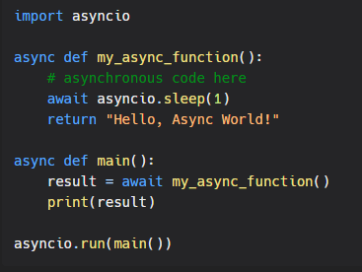
Another way to schedule tasks concurrently is as follows:
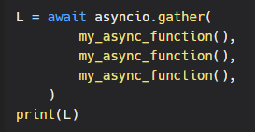
Async IO is a powerful programming pattern that allows for high-performance and concurrent I/O operations in Python. With the asyncio module and asynchronous functions, you can write efficient and scalable code that can handle large amounts of data and I/O operations without blocking the main thread. Whether you're working on web applications, network services, or data processing pipelines, async IO is an essential tool for any Python developer.

